Modern Management Project

Project Requirements:
- Groups & leaders
- Contract
- Topic & references
- Paper
- Presentation

(1) Groups & Leaders:
- Create a group of 5-6 students
- Assign one of group members to be the leader
- Give your group a name
[submit it by filling up this form: http://goo.gl/forms/TbYJNVql4D ]

(2) Contract:
A contract is used to govern how team members will work together, to help the group members to work professionally. It usually includes:
- Group name, group leader, project members, and their signatures.
- Project title, and a brief of the idea of the project (a line or two on the problem)
- How the work will be distributed, and the responsibility of each team member (work should be distributed evenly on group members).
- Dates for meetings (and attendance of that).
- Dates for submissions’ deadlines, and rehearsals on the presentation.
- Means of communication, e.g. offline (face-to-face), online (emails, shared calendar, google drive, WhatsApp, Skype…etc.
- Conditions, e.g. everyone should attend the meetings, submit all work on time, and be prepared before meetings (if needed, depending on the purpose of the meeting).
- What to do if any of the members doesn’t follow these conditions repeatedly, e.g. inform this member and discuss with her that she needs to do the work, if not, then inform your teacher.
[Show it to your teacher as soon as possible. Then include it with your paper for submission in this form: https://www.cognitoforms.com/PNU1/ModernManagementProjectSubmission]

(3) Topic & References:
Each group should consult the teacher on the topic and the problem they will cover. Each group should send:
- The group name (and members & section)
- The topic, the problem in brief, the company, and any other necessary details (two lines only)
- The initial references they’re going to use for this topic
If the teacher agrees on the topic and references, then go ahead and work on the rest of the project.
[Submit it through email (word file not Pdf) and can discuss it in office hours or after classes]

(4) Paper
- Remember! The focus is on quality not quantity!
- No Plagiarism(use online plagiarism checker, e.g. https://www.plagtracker.com/upload/)
- Use good credible references (e.g. Harvard Business Review articles HBR)
- Link the problem to what you have studied

Paper Structure:
- Cover page
- Table of contents
- Introduction/company background
- Problems/challenges
- Solutions
- Conclusion/summary/your opinion
- References
Formatting Rules:
- Number of pages: 7-10 pages
- Font: Times New Roman
- Font size: 12 point
- Margins: one inch (2.5 cm)
- Spacing: 2.0 (double-spacing)
- Justification: left
- First Page: the title, your name, your instructor's name, the course number, the date
- Header: the title, and page number
- Italicized: any name
References:
You should use both in-text citation (the short brackets inside the paragraph), and the list of references on the last page.
Use one of the following styles:
- Harvard Reference Style, http://files.ithuta.net/OpenJournals/HTS/Author/HTSREF.pdf
- MLA Reference Style
These videos might help you in using the automatic references generator in MS Word:
- http://www.youtube.com/watch?v=oYe5RUWW73A
- http://www.youtube.com/watch?v=19-E1OCdvbY

To select MLA style (or Harvard style):
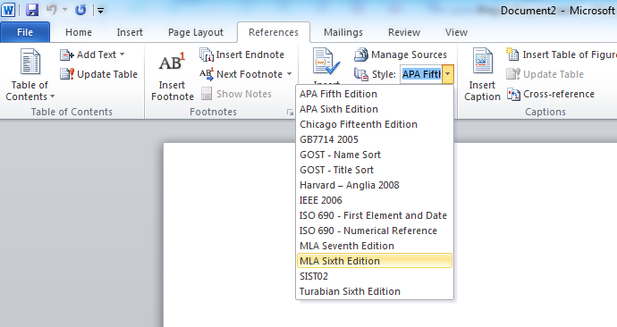

To select a “Web Site” as a type of reference:
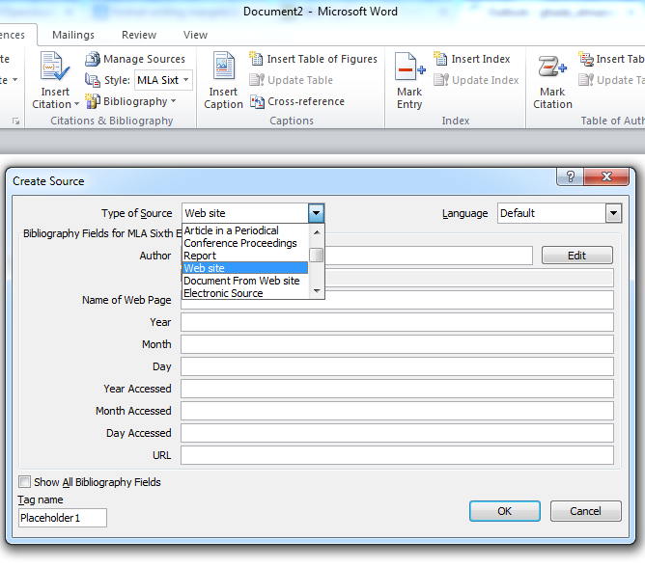
[Submit the paper through this form: https://www.cognitoforms.com/PNU1/ModernManagementProjectSubmission (word file not Pdf) (the teacher may ask you for a hard “printed” copy if needed)]
(5) Presentation:
- All group members should present a part of the presentation (Presentation evaluation is individual)
During presentation:
- Professional appearance (clothes)
- Language: English (can only describe new vocabulary “word” in Arabic)
- Clear voice (not too high or too low / not very fast or very slow)
- Eye contact with audience
- Don’t read from the slides (you can use notes in your hand to only remind you of some extra points, but you should not be reading from them all the time)
- Ability to answer questions (all group members should know all parts of the research, so they can answer any question from any part)
- Manage time (5-7 minutes divided equally within group members)
- Use the right body language

Slides should be:
- Clear
- Organized content
- Not crowded (no too much text in the slides, only brief points)
- Text color contrasts with background color (so you can read it easily)
- Figures/pictures are supporting the idea (if you have any pictures)
- No excess use of “Slide Animation”
- Cover all main points in the research (introduction, problems/challenges, solutions, summary and suggestions)
- Logical sequence of information presentation
- You can use PowePoint or Prezi or any other tool. (if you use Prezi, make sure it works in the class)
[Present. And, submit the presentation through this form: https://www.cognitoforms.com/PNU1/ModernManagementProjectSubmission (the teacher may ask you for a hard “printed” copy if needed)]

Grading
Item | Mark
Paper (with contract) | 4
PowerPoint or Prezi | 2
Presentation | 2
Total | 8

