How to Use a Free Online Plagiarism Checker/Detector?
e.g. Go to: http://smallseotools.com/plagiarism-checker/

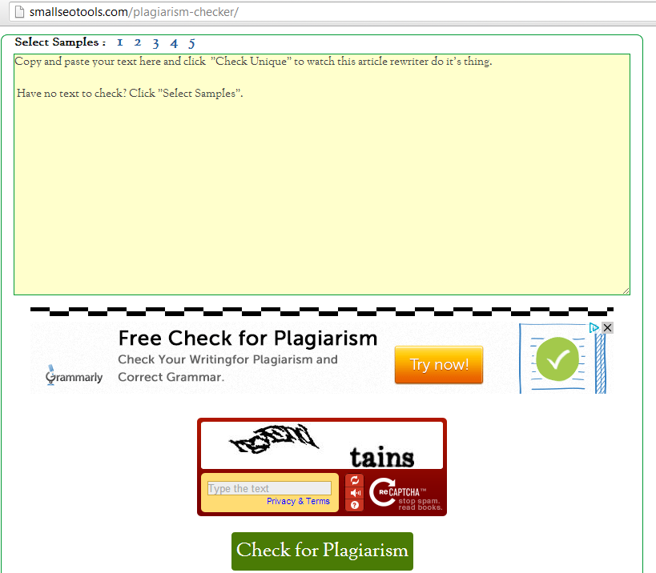
1 Insert your text here
3 Click here to check
2 Insert the code as shown

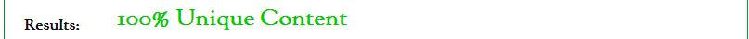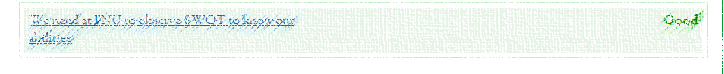
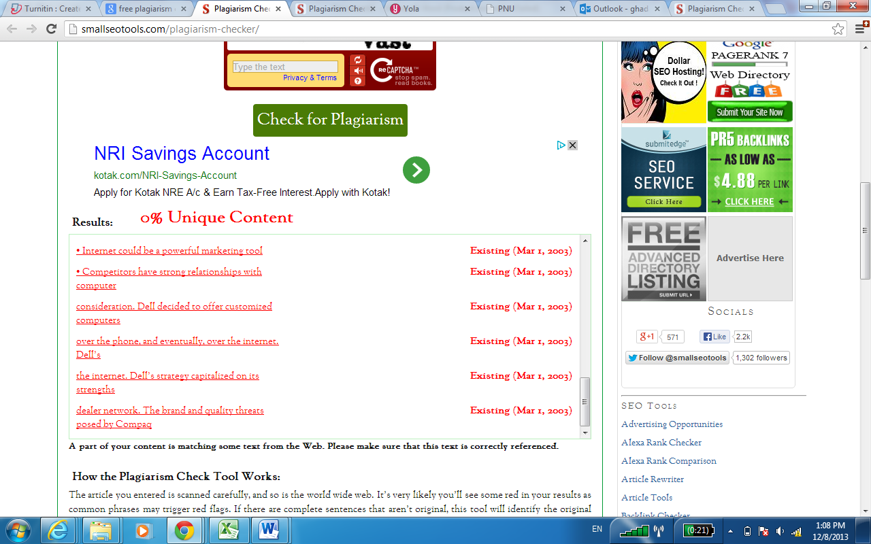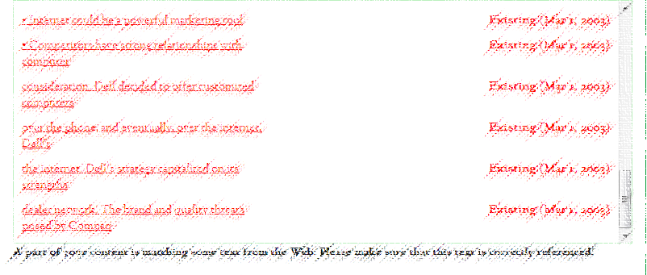
4 See your result

